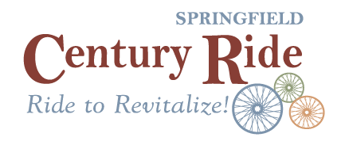
The Springfield Downtown Development Authority (DDA) is hosting its annual Springfield Century Ride for 2024! This year’s ride will be on April 27th. This event, started as the Mars Theatre Bike ride, has continued to grow and offer riders a great opportunity to see Springfield and Effingham County. Funds from this event have supported beatification projects in Downtown and funds will continue to be used for support of the DDA’s efforts to offer grants and assistance for downtown businesses! We are asking local businesses to help support our effort by sponsoring this event. With your sponsorship, you will not only be promoting your business, but will be supporting our continued efforts to Revitalize Springfield and grow our Downtown! Donations of any amount are appreciated, or you can select one of the options below. If you have any questions, you can email Erin Phillips at ephillips@springfieldga.org. Thank you!
___ Merchant $25
Donate and Item for our Raffle and have the option of including collateral in our swag bags or a sign on site.

___ Bronze Level $50
Bronze Sponsors receive recognition at the event with a company sign at registration and along the course! You will have the option of adding marketing materials into the riders SWAG bags.

___ Silver Level $100
Silver Sponsors receive recognition at the event with a company sign at registration and along the course. You will be allowed to set up at the event to showcase your business, and have the option of adding marketing materials into the riders SWAG bags. You will be listed as sponsor of one of our raffle prizes!

___ Gold Level $250
Gold Sponsors receive recognition at the event with a company sign at registration and along the course. You will be allowed to set up at the event to showcase your business, and have the option of adding marketing materials into the riders SWAG bags. You will also receive one free race registration and be listed as a sponsor of two of our raffle prizes!

___ Platinum $500
Platinum Sponsors will receive all the perks of other levels and be listed as a race Co-host for the year. You will also receive two free race registrations.

Please select your Sponsorship Level above and fill out the information on the back of this form.
Sponsor Info:

Company Name: ______________________________________________________________________
Mailing Address:_______________________________________________________________________
Contact Person: _______________________________________________________________________
Phone/Email:__________________________________________________________________________

Check here if you will be providing a promo or advertising item for the rider swag bags.

Check here if you will be using the free registrations that come with your sponsorship level
(Gold and above only)

Check here if you will be coming onsite during registration to advertise your business.
(Silver and above only)

Once your sponsorship level is confirmed, we will send you an invoice.

